

**Management of Data Science and Business Workflows**

**H420**

**Assignment – 1**

**Date – 15th October, 2023**

**Submitted By**

Sony Shrestha

Aayush Paudel

**Question 1**

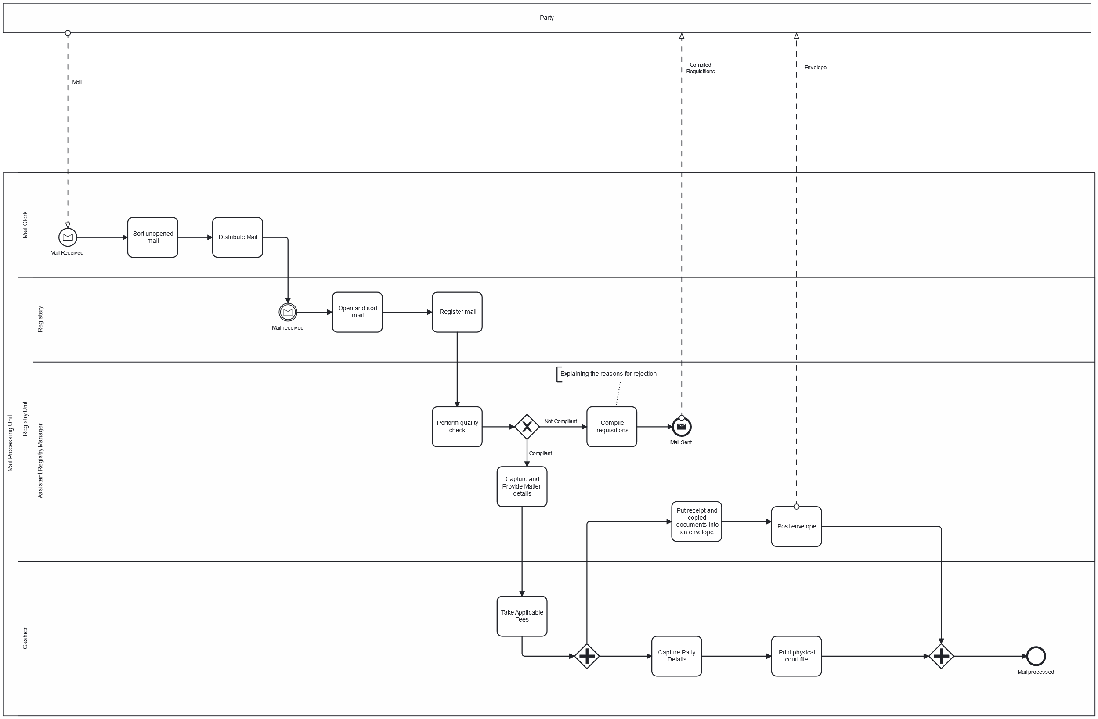

The process starts after receiving mail from party by Mail Clerk. So, Start Message Event has been created.

The resource class Mail Processing Unit (pool) is composed of resource sub classes (lanes) like Cashier, Mail Clerk and Registry Unit (which can further be decomposed into Registry and Assistant Registry Unit).

OR-Gateway is used to represent two exclusive activities performed after Quality Check, that includes either compiling requisitions - if the mail is compliant, or capturing and providing matter details - if the mail is compliant.

To indicate parallel activities performed by Assistant Registry Manager and Cashier, AND gateway is used.

A separate pool is used to represent Party from whom mail is received at the start of event, to whom the compiled requisitions and envelope are sent from Mail Processing Unit during the process.

**Question 2**

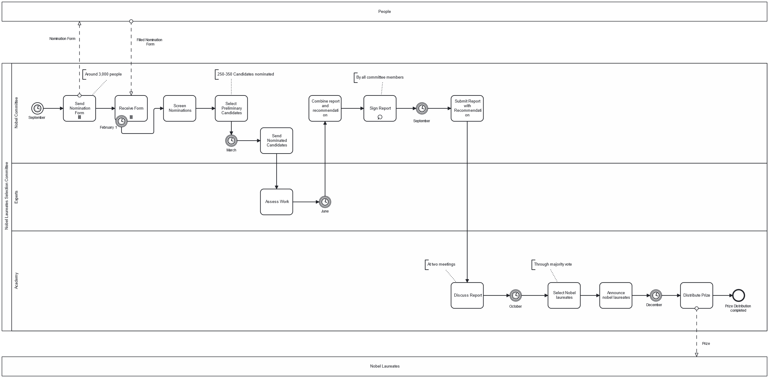

The process starts on September. So, Start Timer Event is used at the beginning.

Since sending and receiving nomination form happens in parallel for around 3,000 people, parallel activity is used to represent them.

Nobel Committee should stop receiving form after the end of January and interruption occurs on February 1, which is indicated by Interrupt Timer Event.

As Sending Nominated Candidates activity does not start until March 1, Intermediate Delay Event is used prior to this activity.

The report is signed by all the members of committee. Since, this activity happens one after another in a loop, it is represented using Activity Loop.

Since, Academy, Experts and Nobel Committee (resource sub classes/lanes) work together as a part of Selection Committee in order to choose the best candidates for Nobel Prize, Nobel Laureates Selection Committee is represented as a single logical class (pool).

A separate pool is used to represent People, who are responsible for filling up nomination form and Nobel Laureates, who will be awarded with the Nobel Prize.

**Question 3**

Following things are wrong in this model.

1. Start Message Event should be added in small claims tribunal pool. This event starts with the message flowing from party.
2. The way Claim File, Report and Expanded claim file are being represented is incorrect. Data object needs to be used in other to represent them.
3. In order to represent Await Report, Start Timer Event is being used. Instead, Intermediate Timer Event should be used to represent such delay.
4. Activity Archive Claim and End Event should be in Small Claims Tribunal Pool.
5. Activity Notify Party should be replaced with Message Send Event.
6. Notification between Small Claims Tribunal and Party should be represented as Message Flow.
7. Since, Await Report event waits for the report from the police, it should occur after the report is received from the police.

The corrected BPMN diagram is as follows:

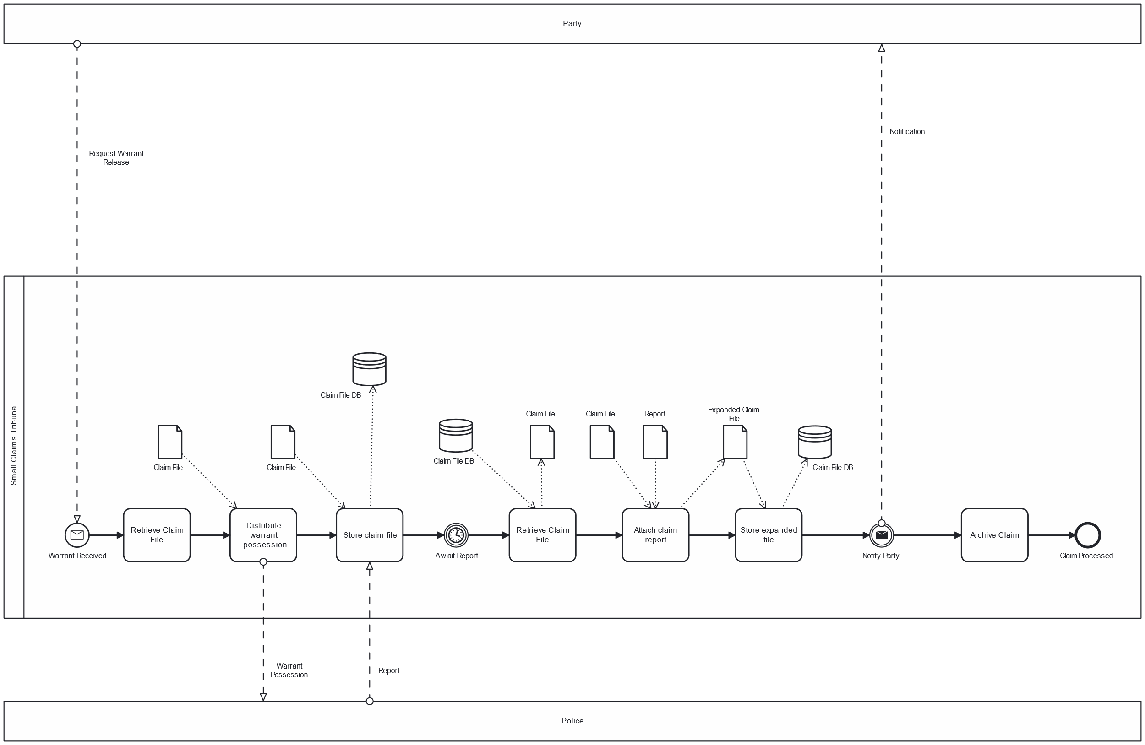

**Question 4**

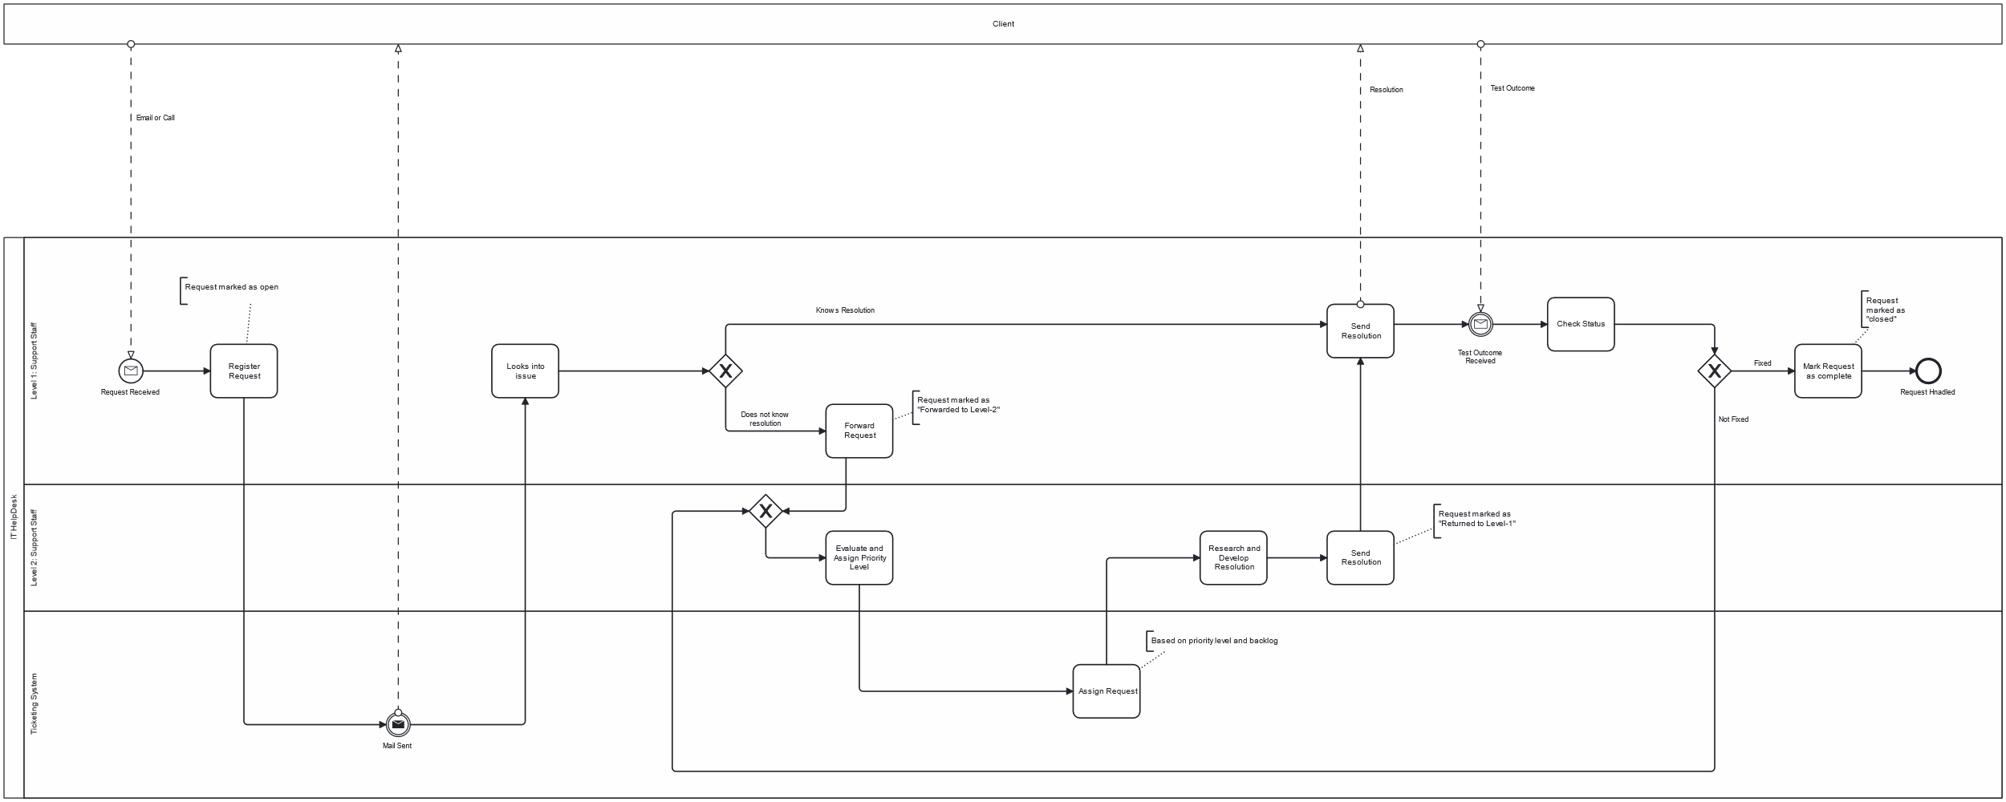

The process starts after receiving mail or call from the client by IT Help Desk. So, Start Message Event has been created.

With the help of Intermediate Message Sent Event, ticketing system sends message to the client as soon as request is registered into the system.

In order to represent the state of the request, annotation is being used.

The resource class IT Help Desk (pool) is composed of resource sub classes (lanes) like Ticketing System, Level1: Support Staff and Level2: Support Staff. Since, ticketing system is the technology being used for assisting the registration process, this can be considered as the part of IT Help desk.

A separate pool is used to represent the client from whom request is received at the start of event, and to whom the resolution for the issue is sent.